

WEB DESIGN

PROJECT REPORT

###### Project Team

|  |  |  |
| --- | --- | --- |
| Student No | Student Names | Notes |
| 16135296 | Elmarie Fryer |  |
| 16135261 | Filip Minarik |  |
| 16137621 | Patrick Young | Patrick was out sick from Monday 27th March to Monday 4th April at which point he decided to withdraw from the course. Patrick was involved in the initial design, but was not involved in the updated designs, nor did he do any of the coding of this website. |

###### Deployed Site

|  |  |
| --- | --- |
| Website Name | Yellow Cup House |
| URL of Deployed Site | http://yellowcuphouse.gear.host/ |

Table of Contents

1. PROJECT PROPOSAL 1

1.1. Project Overview 1

1.2. Research / Investigation 1

1.3. Requirements & Technical Approach 3

2. WIREFRAME / SITEMAP 4

2.1. Sitemap 4

2.1.1. Wireframe for the Homepage 5

2.1.2. Wireframe for the other pages 6

3. PRODUCTION LOG 9

3.1. Overall 9

3.2. HTML Code 9

3.3. CSS Code 9

3.4. JavaScript 9

3.5. Validation 9

3.6. Testing 10

3.7. Deployment 10

4. Project Team 11

4.1. Original Split 11

5. CONCLUSION 11

6. REFERENCES & APPENDIX 11

Section 1: Design

# PROJECT PROPOSAL

## Project Overview

Our website is for the Yellow Cup House. This is a coffee shop that opened in Pearse Street in Dublin 2 during February 2017. It’s owned and managed by a group of friends who all have a passion for coffee, and a desire to run their own business, but no technical expertise in creating a website. At the time we were looking for a plan for our website they only had a Facebook page with very little activity. Most of their marketing was word of mouth and via flyers.

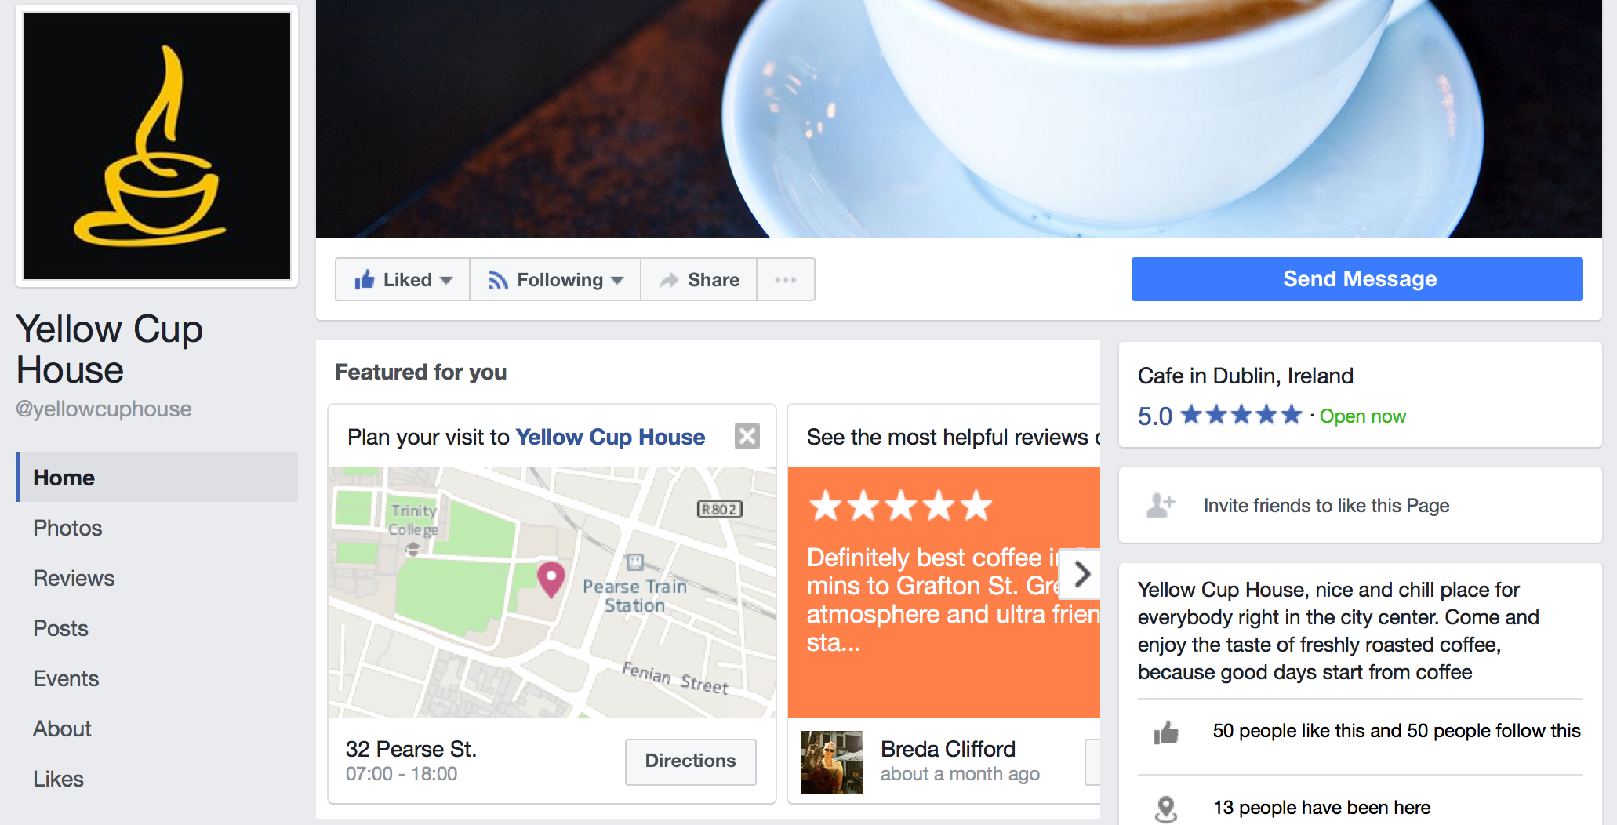

We are designing a site for this coffee shop that the owners can maintain with ease, that is easy to find online, and easy for potential customers to use. In order for this page to be useful as soon as possible it’s imperative that it is mobile friendly as most traffic is likely to be from mobile devices.

## Research / Investigation

As this website is for a real business and they would like to use it our starting point was a discussion with our customer. We talked about what they would like to do with the website and who it was aimed at.

Their main aim for the website is to be found, so if someone is in the Dublin city centre and wants a coffee, then this website should come up. They would also like a map (e.g. google maps) to allow people to find them. They would also like the website to allow future expansion. At the moment they do coffee and lunch, but they are in the process of obtaining licencing to serve alcohol which will expand their business. When that happens they would like to add to the website with ease.

These are the requirements our customer wrote down before we met:

* Easy to navigate
* Must have a warm feeling
* Facebook and Twitter links
* Searchable
* Easy to use on a mobile device
* Google maps to navigate to the shop
* Visitor counter (in the background) if at all possible
* Pages to include: gallery, feedback and other comments
* Special offers

We also looked at local (Dublin) coffee shop websites. It turns out that many local coffee shops only use Facebook or twitter for example: <https://twitter.com/ViceCoffeeInc> ; <https://www.facebook.com/properordercoffeeco/>; <https://www.facebook.com/BirdcageBakery>.

Others are only listed in online guides, e.g. <http://www.sidewalksafari.com/2014/10/dublin-eats-blonde-cafe.html> or are part of a larger site, e.g. <http://www.fallonandbyrne.com/> .

These are the sites we found most similar to the business for which we’re building a website.

* <http://urbun.ie/>
* <http://www.kaph.ie/>
* <https://coffeeangel.com/>
* <http://wallandkeogh.wixsite.com/wallandkeogh>
* <http://shpetite.ie/>
* <https://brotherhubbard.ie/>
* <https://www.roastedbrown.com/>
* <http://thefumbally.ie/>
* <http://twofiftysquare.ie/>
* <http://www.vicecoffeeinc.com/>

We also found a page with the top 100 coffee shops in the US that we looked at for ideas even though they are clearly not competitors of the Yellow Cup House.

From our research into similar businesses and talking to our customer we found the following aspects that we want to incorporate into our website:

Look and feel:

* A warm colour scheme with lots of rich, earthy tones.
* Inviting photographs of the space. Not too many though – lots of photo’s look very “busy” and we’re creating a relaxing atmosphere on the page. Photo’s used should be colourful and enticing.
* Consistency in font – it looks terrible when the fonts don’t match and great when an “informal” font is used – fits in with the warm, relaxed atmosphere the site should invoke.

Navigation:

* Everything on one page is just awful. Having to scroll and scroll is very irritating.
* Some sites look terrible on android devices – we didn’t have an iPhone at the time, but it’s clear we have to test our site on Android and an iPhone in addition to a browser.
* We have to link to other social media sites in an easy way.

Content:

* The best sites all have maps.
* An easy way to sign up to newsletters and specials – no more than Name and e-mail address should be included as a default. To fiddly takes too long.
* Prices should be clearly displayed and easy to find, as should the opening hours.
* The better sites have a page on where the coffee comes from as they pride themselves on that. We must get contents from the business owners

Maintainability:

* We should make it very easy for the owners to update the pages. This will require several stylesheets. One overall one for the look and feel, and separate style sheets for the layout as well as page specific items. That means that the html pages will be uncluttered and easier to maintain.

## Requirements & Technical Approach

The requirement for this project is to develop a website consisting of a homepage and several additional pages. There will be at least 3 style sheets. An overall stylesheet for consistent look and feel, a style sheet with the layout for the home page, and a style sheet with the layout for the other pages. In addition, there may also be style sheets required for individual pages if needed – we will determine this later as we start coding the pages.

To best work as a team we will follow a hybrid agile approach where we will divide the work into minimum viable products. Each of us will work on one of these and we will then combine our results. This will only work if we plan the overall structure together.

# WIREFRAME / SITEMAP

## Sitemap

The first step was to design a sitemap that included all the customer’s current requirements, but would also be scalable for future expansion. As one of the things we found on the sites we visited was that excessive scrolling and clicking was annoying we decided on no more that 3 layers.

We also decided on page names for html so that it makes building links on the various pages easier.

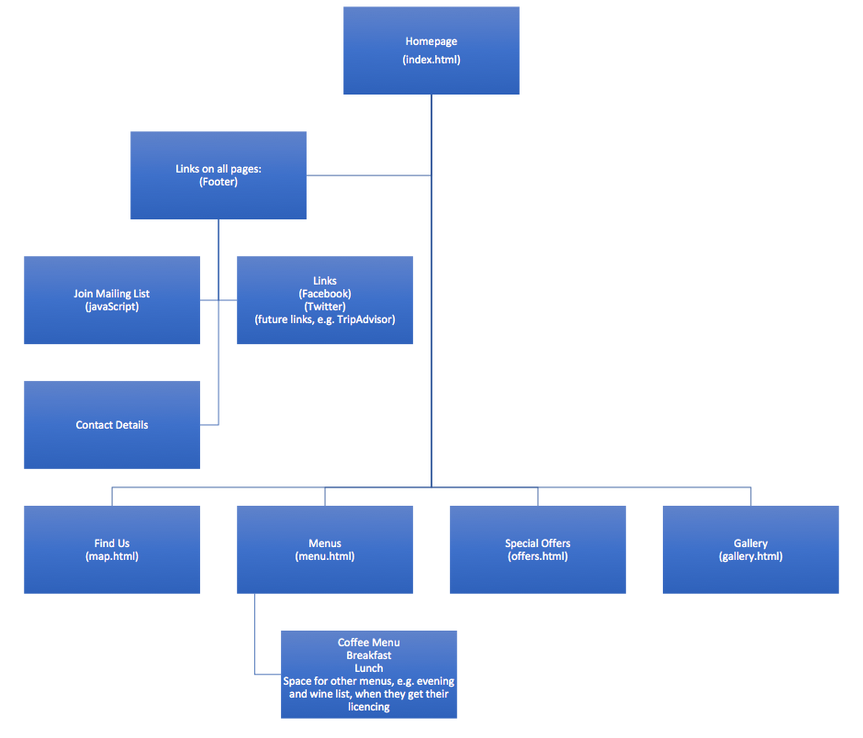

Given that the owners of this site want to be able to maintain and update the specials and menus on a regular basis and may want to add in additional pages, and given that they are not technically minded, we decided to keep it simple by having only two types of pages, a home page and the rest.

All pages other than the home pages to follow the same design and layout. This will ensure consistency, reduce errors, make it easy to add more pages if required, and improve security of the site.

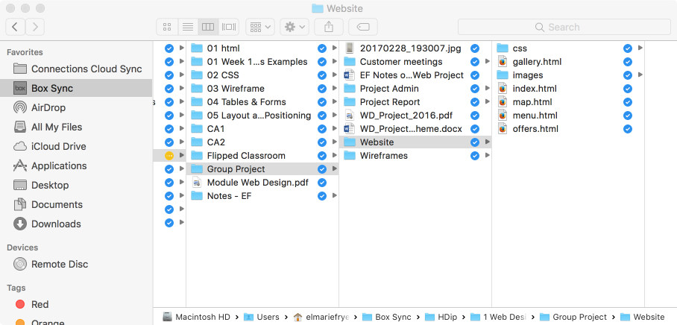

We drafted a high-level design to use as the basis of our wireframes.

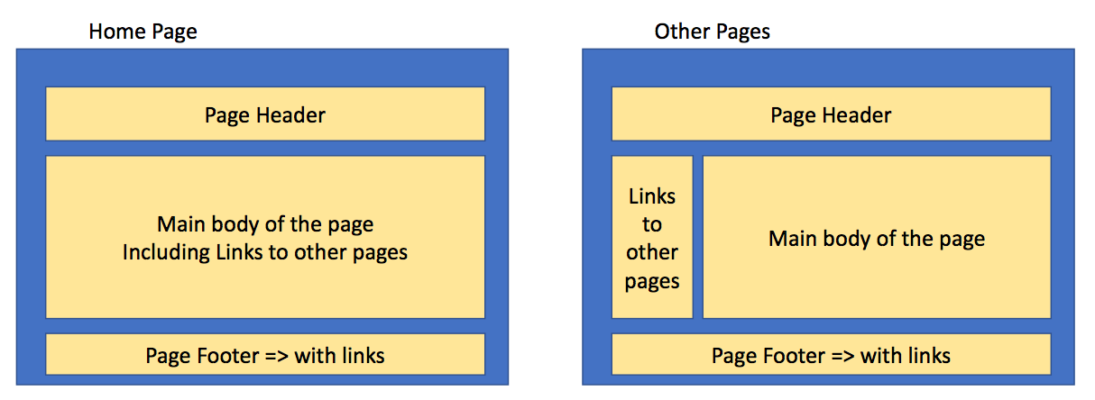

### Initial Wireframe for the Homepage

(Patrick Young’s contribution to this report is the wireframe for the Homepage – initial design before showing to customer)

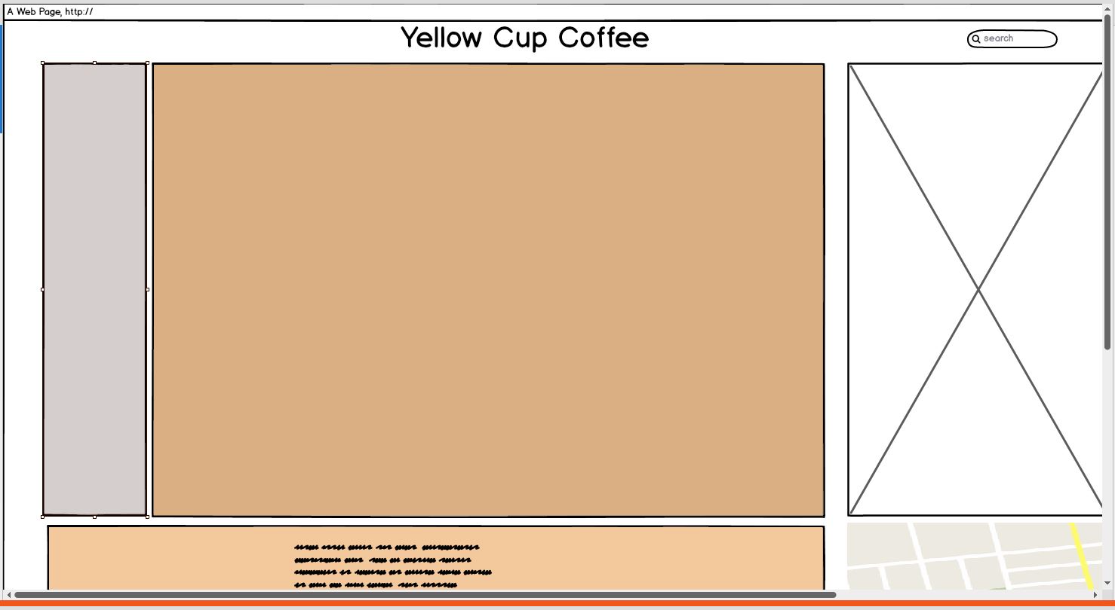

### Initial Wireframe for the other pages

All pages other than the home pages to follow the same design and layout. This will ensure consistency, reduce errors, make it easy to add more pages if required, and improve security of the site.

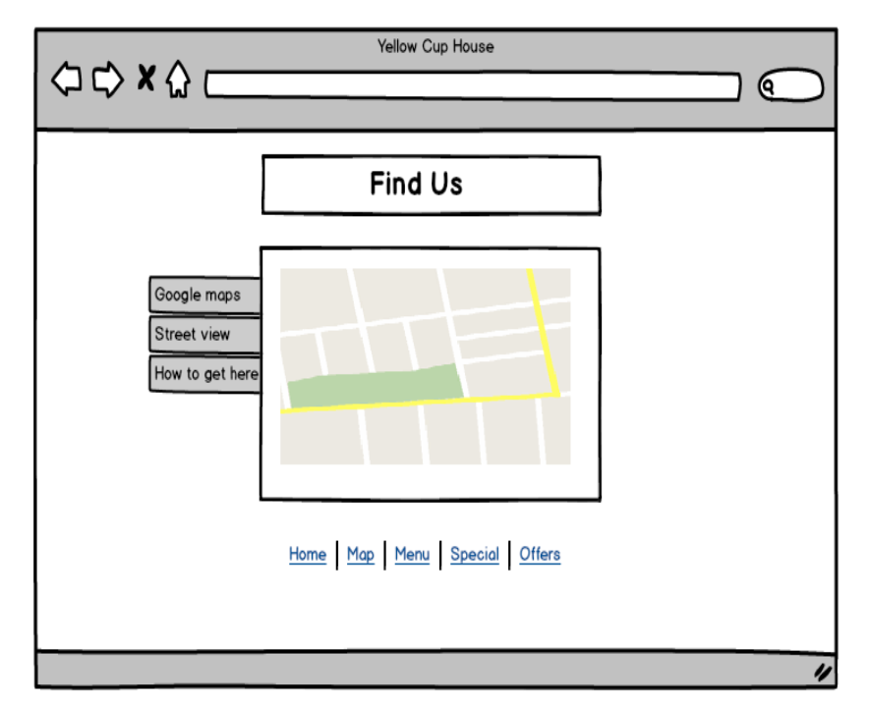

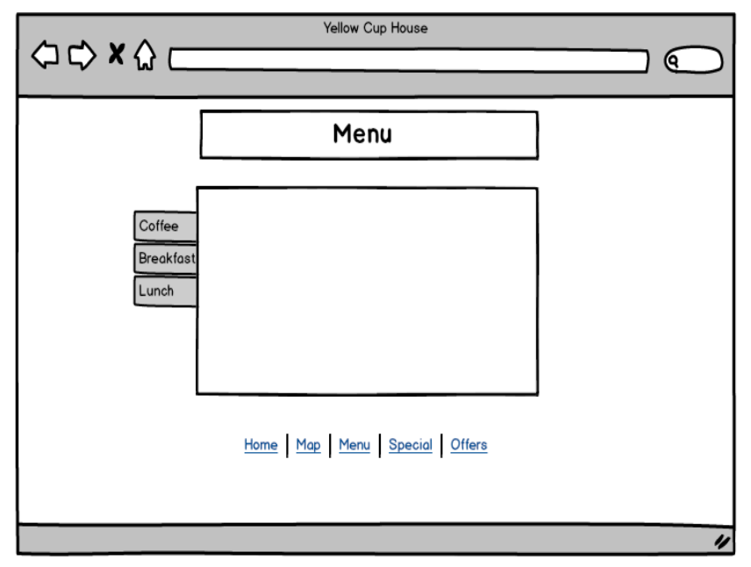

### Updated Wireframes

After completing the initial design stage and subsequently during the development all wireframes were created on paper.

As the team was down to only 2 people we didn’t have the time to create the updated wireframes in Balsamiq. We chose to focus our attention on the actual development.

Here are examples in pdf of the various wireframes we created on paper – annotated with notes as we were discussing them with our client.

Section 2: Development

# PRODUCTION LOG

** This section should outline how you went about developing your webpage, i.e. HTML, CSS, JavaScript. This should include information on requirements implementation, code development and technical details, such as errors or development issues and how you fixed these.

Please note: Make sure to include explanation (as well as comments in the HTML files) of any & all code that was taken from the web, or you will not receive marks for this third party code. **

## Overall

## HTML Code

## CSS Code

The CSS was done in parts:

* Main look and feel
* Header and Footer
* Look and feel of the site (borders, etc.)
* Responsiveness

It took multiple attempts to get the site to look just right and we gave the customer a choice of say two footers.

## JavaScript

## Validation

The validation was a useful exercise.

There weren’t too many html issues, mainly small errors. The two big things to fix were:

* Updating the code we used to drop in the map by removing outdated style elements
* The sizing of all the pictures were originally in percentage, not pixels. That required a bit of research on W3Schools to fix.

The css code validation only had a few small items to correct – mainly typos or missing punctuation (;).

** screenshot(s) of your validation report here **

## Testing

We did the bulk of the development work testing on firebox as that is what both Elmarie and Filip use daily.

In addition to Firefox we also tested in the following browsers once we completed the content, responsive design, and JavaScript.

* Safari (no issues and responsive)
* Internet Explorer 11 (no issues and responsive)
* Android (Samsung Smartphone)

## Deployment

This website was initially deployed on gearhost as that’s the example we used in class. This is not a searchable option for our client and they are pricing alternative hosting sites with a specified domain name. Due to the time and resource constraints for the project we are using the gearhost site for this report.

The live site will have an Irish domain name and will be hosted on a commercial provider like GoDaddy. It’s likely that the form required for our project will be removed as our client prefer dealing with customers by phone or e-mail.

** screenshot of the live site **

# Project Team

Unfortunately, we were a person short for most of this project.

Patrick withdrew from the course in April, but he was out sick at the end of March and only contributed the original Balsamiq wireframe of the homepage.

In terms of the Design and Analysis phase Patrick did contribute in terms of researching coffee shop websites in the US and found some good examples for us.

As Patrick delayed his decision to withdraw from the project we started later than we would have wanted to, but our team meetings were postponed while he was out.

As we were short staffed, we split the work as follows:

* Elmarie did the CSS, including the responsive design
* Filip did the JavaScript
* The Html was a joint effort using Git & GitHub and meeting up regularly.
* Elmarie got the original content and Filip followed up with the client for the text on the homepage.
* The report was a joint effort

## Original Split

The original idea was to split the work as follows:

* The Css would be broken into 3 parts – the overall look and feel (header and footer); the layout of the homepage; and the layout of the other pages (which were going to be the same)
* The html would be split into 3 parts – the homepage; 2 pages, and 2 pages
* Javascript – one each, and an extra one for the person who didn’t have a form on their page or the report to do.

Once Patrick left that didn’t work.

# CONCLUSION

Being a team of two was challenging due to lack of time, but at least once we had clarity we could start working away.

This site is for a real business which had the benefit of allowing us to interact with a real client, but also meant we had to do a good job and in some cases go with the customer’s requirements, rather than our own inclination.

We would have like to change the text on the homepage but it was written by our client - as it should be.

We would have loved pictures of lots of people having coffee in the shop, but again we had to work with what we got - at least the benefit of all the pictures taken by our client is that there isn’t a copyright issue.

We had good ideas for special offers, e.g. a Student Discount, or a button that generates a random code for discount, but our customer wasn’t interested. If we had a third person in the team we would have had the scope to create some of these for the site as a demo (and for the project of course) which may convinced our customer to use the functionality.

If we had time, there is great JavaScript that allows the picture to change when you hover over it. If we were a team of three we would have implemented it.

# REFERENCES & APPENDIX

** Make sure to include any third party resources / information / code used here.

Make sure to reference correctly as needed, i.e. Harvard Referencing, or marks will be deducted. **

Google US. 2017. Learn to make great sites | Google Webmasters – Google . [ONLINE] Available at: <https://www.google.com/webmasters/learn/>. [Accessed 12 April 2017]

Tryit Editor v3.3. 2017. Tryit Editor v3.3. [ONLINE] Available at: <https://www.w3schools.com/howto/tryit.asp?font=Comfortaa>. [Accessed 08 April 2017]

YouTube. 2017. Responsive Web Design for Beginners - How to get started in 3 steps - YouTube. [ONLINE] Available at: <https://www.youtube.com/watch?v=Up_NC-qGzuI>. [Accessed 12 April 2017].